**Anticipating Dividend Cuts**

**Ziyao Zhang, Chengyi Xu, Alex Dominguez**

**Carey School of Business, Johns Hopkins University**

**BU.232 Empirical Finance**

**Dr. Sudip Gupta**

**May 18, 2023**

**Executive Summary:**

For this project, we choose the topic of Event study. Our main goal for the topic is to analyze the impact of the divided cut on various dimensions. A dividend cut occurs when the company paying the dividend stops paying it altogether or reduces the amount it pays. This usually results in a sharp drop in the company's share price, as it is usually a sign of weakness in the company's financial position, which makes the company less attractive to investors. We would analyze how the event of a divided cut affects our returns by making an analysis of the investor's abnormal return and cumulative abnormal return on both before and after the divided cut, and how would an investor choose the timing to invest considering the fundamentals. Additionally, in order to anticipate dividend cuts or sharp declines, we can analyze financial documents such as 10Ks, 10Qs as well as news articles in order to gain insight on market sentiment towards the underlying asset. While individuals may gain different sentiment insight by manually deciphering documents, we can implement text classifiers to more objectively analyze documents.

**Prediction of Returns with Fundamentals**

**Methodologies**

**Fundamentals Selected:**

* **Dividends per Share:** This is one of the most obvious and direct indicators of a company's dividend policy. If a company cuts its dividend, it will be immediately reflected in this variable. This information can provide a clear picture of how much a company is paying its shareholders.
* **Cash Dividends:** These represent the cash that the company is actually distributing to its shareholders. It's a more tangible representation of the company's profits and its willingness to share them with investors. It directly affects the income an investor receives from owning the stock.
* **Indicated Annual Dividend:** This is a projection of future dividends based on the company's stated policy or recent actions. If a company cuts its dividend, it may affect its indicated annual dividend and thus investor expectations.
* **Current EPS (EPS) and Current EPS Month:** EPS (Earnings per Share) is a direct measure of the company's profitability. It can affect the company's ability to pay dividends and can also affect investor sentiment. If a company's EPS is falling, it may be an indication of potential future dividend cuts.
* **Daily Total Return Factor:** This measures the overall return of the stock, including both capital gains and dividends. A cut in dividends can reduce the total return, which may affect investor sentiment and stock prices.
* **Trading Volume:** This is a measure of liquidity and investor interest in the stock. A high trading volume may suggest that there's a lot of interest in the stock, which could affect the stock's price. A dividend cut may affect the trading volume as it can lead to a change in investor sentiment.
* **Market Capital:** This is the total value of the company's stock. It's a measure of the company's size and its importance in the market. A dividend cut could affect the market capitalization if it leads to a fall in stock prices.
* viii.**Capital Gains:** This is the profit that an investor gets from selling a stock at a higher price than they bought it. A dividend cut can affect capital gains if it leads to a fall in stock prices.
* By choosing these variables, we aimed to understand how a dividend cut can affect various aspects of the company's performance and investor returns. Each variable provides a unique perspective on this event, helping us to build a comprehensive understanding of its impacts.

The two primary methodologies being employed here are:

* Pre-CAR OLS Regression: This regression analyzes the relationship between the predictors and the abnormal return (abret) for each event time. This provides an understanding of how the predictors affect the abnormal return on each day before the event (dividend cut).
* Pre-BHAR OLS Regression: This regression analyzes the relationship between the predictors and the cumulative abnormal return (car) for each event time. The cumulative abnormal return is the sum of abnormal returns over a certain period. This provides an understanding of how the predictors affect the total abnormal return up to each day before the event.

**General Short-Long term Results:**

A p-value less than 0.05 generally indicates a statistically significant result. The closer it is to 0, the stronger the evidence that this variable is significant.

1. For all models (0-9), 'gind' (Industry Classification) and 'gsubind' (Sub-Industry Classification) consistently show significant influence with low p-values, suggesting that the specific industry plays a crucial role in stock performance.
2. 'trfd' (Daily Total Return Factor) appears to be a significant factor for most models except Model 8. This suggests that the daily return rate may be an important factor in stock performance.
3. 'capgn' (Capital Gains) and 'div' (Dividends per Share) show fluctuating significance across models. This suggests that their influence might depend on other factors or conditions present in specific models.
4. 'divd' (Cash Dividends) shows varying levels of significance across models but tends to be significant more often than not.
5. 'eps' (Current EPS) and 'epsmo' (Current EPS Month) generally show less significance, suggesting that they might not be key drivers of stock performance in the given models.
6. 'marketcap' (Market Capital) appears significant in some models but not all, indicating its influence may also be contingent on other factors.
7. 'cshtrd' (Trading Volume) also shows varying significance, suggesting its effect may be model-dependent.
8. The overall model p-value (F-statistic) for all models is well below the significance threshold (0.05), indicating that each model as a whole significantly explains the variation in the dependent variable. The lowest p-value was observed in Model 7, suggesting that this model may provide the best fit among the options.

**Sentimental Analysis**

**Methodologies**

* In order to process financial documents for sentimental analysis, we utilize the SEC API, which allows us to extract 10ks, 8ks. There are some limits to the API however, which limit how many requests are allowed within a given month. As a result, we decide to focus on certain stocks.
* After downloading the documents, we need to split the data into 512 word segments in order to be compatible with a FinBert trained model.
* The first documents analyzed were entirely 10ks. Secondly, the MD&A segment of the document was isolated in order to prevail closer details.
* In order to assess this more carefully, we set counters to count when segments are positive, negative or neutral.

**Analysis**

* The overall 10Ks were neutral and did not provide much information on future movement.
* After breaking down to only MD&A, there is a larger portion of negative sentiment. This makes sense since this section speculates of future performance as well as current risk.
* Histograms showed that most documents are filled with neutral sentiment and only a fraction are clearly positive or negative.
* Leading up to the dividend cuts some stocks saw an increase in negative sentiment, but still did not give clear forecasting for future downturn.

**Results**

* There are no clear/universal trends that predict dividend splits. Most of the 10Ks section 7 were neutral and even have higher portions of positive sentiment over negative sentiment.

**Conclusion and Recommendations:**

1. In the short term, if an investor believes the dividend cut is going to happen at a certain day before that happens, the best day to invest is 10 Days earlier, generating both the highest abnormal return and cumulative abnormal return.

If the investor realized the event of dividend cut after the event happened, then they should invest at 1 Day after the event announcement, in the considerations of abnormal return. If the investor considers more about cumulative abnormal return, then the best day to invest after the event announcement is 7 days later.

2. In the long term, if an investor believes the dividend cut is going to happen at a certain day, the best day to invest is eight days earlier, generating the highest abnormal return. If the investor considers more about the Buy-Hold abnormal return, then they should enter 10 days earlier.

If the investor realized the event of dividend cut after the event happened, then the best day for him/her to invest is 0 Day (immediately) after the event announcement, in the considerations of abnormal return. This is also true for the Buy-Hold return.

3. In the short run, generally, the investors should consider stocks that pays LOWER Dividends per Share; HIGHER Cash Dividends; LOWER Indicated Annual Dividend; LOWER Current EPS (EPS) and LOWER Current EPS Month; HIGHER Daily Total Return Factor; HIGHER Trading Volume and HIGHER Market Capital; HIGHER Capital Gains.

In the long run, generally, the investors should consider stocks that pays HIGHER Dividends per Share; LOWER Cash Dividends; LOWER Indicated Annual Dividend; LOWER Current EPS (EPS) and LOWER Current EPS Month; HIGHER Daily Total Return Factor; LOWER Trading Volume and HIGHER Market Capital; LOWER Capital Gains.

4. Using financial documents alone, it is unlikely to predict financial events. Only after certain events, such as dividend splits do these trends seem clearer.

5. To provide higher accuracy, more filings would need to be examined and perhaps incorporate more parameters in the training model in order to capture external future factors.

Works Cited

Apple Inc. (2018). *Form 10-K 2018*. U.S. Securities and Exchange Commission. <http://pdf.secdatabase.com/1033/0000320193-18-000145.pdf>

Apple Inc. (2019). *Form 10-K 2018*. U.S. Securities and Exchange Commission.<https://www.sec.gov/Archives/edgar/data/320193/000032019319000119/a10-k20199282019.htm>

Apple Inc. (2021). *Form 8-K 2018*. U.S. Securities and Exchange Commission<https://www.sec.gov/Archives/edgar/data/320193/000119312521328151/d259993d8k.htm>

Services, Wharton Research Data. “Wharton Research Data Services.” *WRDS*, wrds-www.wharton.upenn.edu/. Accessed 18 May 2023.

**Appendix:**

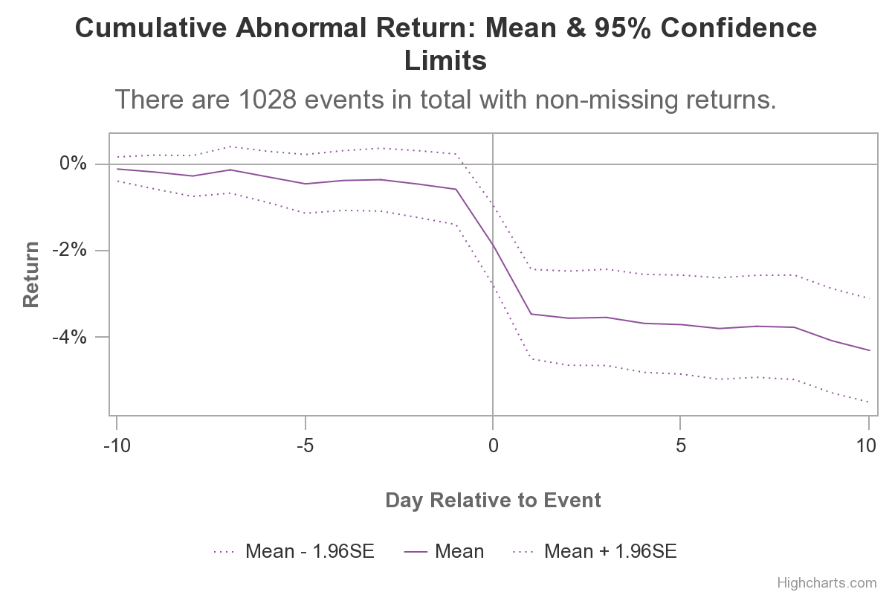

Graph 1 depicts the CAR 10 days before and after the dividend cut date. There is a statistically significant decline between one day before and after the dividend cut is announced.

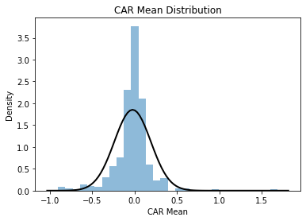

Graph 2 shows the distribution of CAR. Since the mean centers around 0 and is approximately normal, the market is highly efficient when it comes to correcting after announcement.

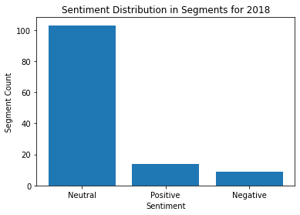

Graph 3 shows a plot for Section 7 from Apple’s 2018 10K. Interestingly, there was more positive sentiment than negative sentiment two years before dividend cut.

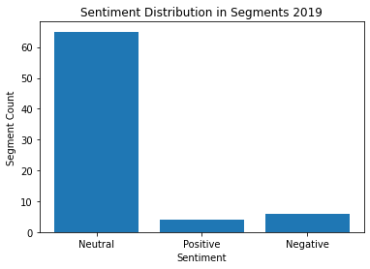

Graph 4 shows a similar plot as Graph 3, but focuses on 2019, one year before the dividend cut. There is an increase in negative sentiment, but not anything indicating massive moves downward. It is roughly the same amount of negative sentiment as positive sentiment from the year before.